Muscle disorders, such as muscular dystrophy or polymyositis. Diseases affecting the connection between the nerve and the muscle, such as myasthenia gravis. Disorders of nerves outside the spinal cord (peripheral nerves), such as carpal tunnel syndrome or peripheral neuropathies.

The aim of this paper is to construct an automatic system of neuromuscular dysfunction identification in the case of the Parkinson disease based on surface EMG (sEMG) signals. Our proposed system uses artificial neural network method (ANN) to discriminate healthy EMG signals (normal) from abnormal EMG signals (Parkinson). After detecting the EMG activity regions using Fine Modified Adaptive Linear Energy Detecor (FM-ALED) method, Discrete Wavelet Transform (DWT) has been used for feature extraction.

Parkinson’s disease symptoms such as bradykinesia, rigidity, tremor and gait disturbances are sources of major disability.

Gait disturbances--- **Walking problems may cause you to:**

Walk with your head and neck bent over.

Drag, drop, or shuffle your feet.

Have irregular, jerky movements when walking.

Take smaller steps.

Several techniques are used for PD classification such as : probabilistic neural network (Okamoto et al., 2009), support vector machine (SVM) (Surangsrirat et al., 2016), K-means clustering algorithm (Bhoi, 2017). In (Elamvazuthi et al., 2015), the ANN using linear prediction coefficients (LPC) features is developed to classify neuromuscular disorders (myopathy and neuropathy disorders).

One of the ANN major advantages is its ability to represent both linear and non-linear relationships (Oskoei and Hu, 2007) (Reaz et al., 2006). Many studies have adopted this technique to classify time domain features using multilayer perceptron (MLP) as well as linear discriminate analysis (LDA) to achieve high classification accuracy up to 95 %

The learning phase consists in modeling the two classes P and N (P: Parkinson and N: Normal), while the test phase aims to evaluate the performance of the classification systems using the ANN and K-NN method. These two phases require a step of extracting discriminating parameters from the two classes.

There are mainly three types of parameters which characterize the MUAP waveform such as: amplitude, duration and stability

Neuromuscular diseases change the shape, characteristics of the MUAP and the firing patterns of the motor unit (MU) are also changed. In normal conditions, MUAPs show mean peak-to-peak amplitudes of around 0.5 mV and duration from 8 to 14 ms, depending on the size of the MUs. In neurogenic disorder, the amplitude is increased to achieve 5 to 10 times normal and the duration is also increased.

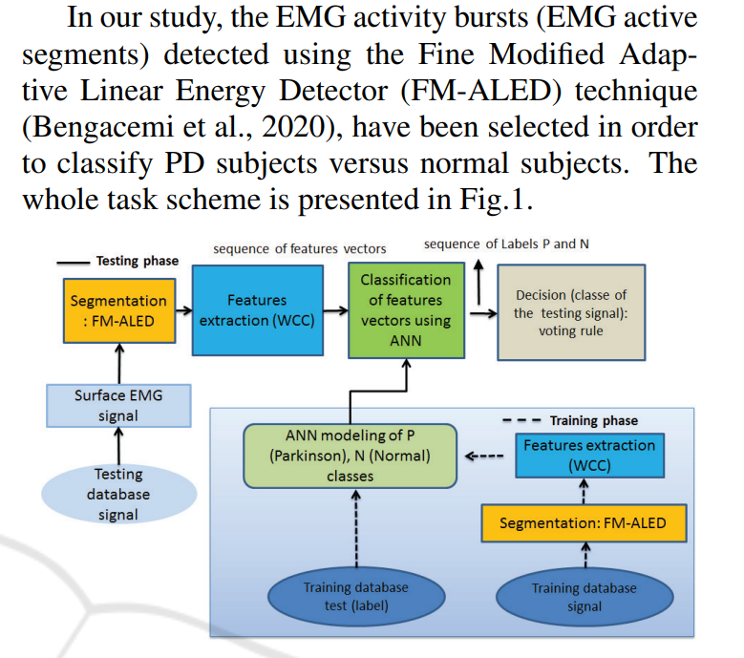

The proposed classification system is composed of learning and testing phases. The learning phase consists of detection of EMG activity segments, extraction of features, modeling of the two classes P and N using the ANN method. The testing phase consists of detection of EMG activity segments, extraction of features, classification of each vector of features by ANN technique, then classification of the sequence of vectors of each signal from the test database using the voting rule in order to find the dominant class from this sequence.

A specific lower limb muscles of gait activity have been measured. EMG sensors were placed on the muscle belly parallel to the main direction of muscle fibres. Data were collected using an on board system of wearable sensors (20-450 Hz bandwidth, 16 bits per sample, 1926 Hz sampling rate). Data collection provides several burst activities from each right soleus muscle corresponding to several gait cycles.

( For ALED method ---

<https://ieeexplore.ieee.org/stamp/stamp.jsp?tp=&arnumber=7958651>

The proposed technique is based on an energy detector method named Adaptive Linear Energy Detector (ALED) [8]. This technique is usually used in Voice Activity Detection for identifying the speech and non-speech segments in an audio signal. It has been also employed in VoIP (Voice over Internet Protocol) systems [9], speech recognition [10], voice compression and coding [11], hands-free telephony and audio conferencing. )

FILTERING AND RECTIFICATION STEP (EMG SIGNAL PRE-PROCESSING )==== In this study, the FM-ALED technique is used to identify and extract the EMG activity segments in order to eliminate the non EMG activity regions (noise regions).

Next STEP IS FEATURE EXTRACTION ----

THE VARIOUS METHODS THAT CAN BE USED ARE HERE-

<https://www.researchgate.net/publication/51997893_Techniques_for_Feature_Extraction_from_EMG_Signal>

In our work, we are interested in the use of Discrete Wavelet transform, particularly the Wavelet Cepstral Coefficient (WCC) coefficients. All the features were calculated using the discrete wavelet transform (DWT) which mother wavelet is characterized by two digital low-pass and high-pass filters.

For this task, the mother wavelet Coifficient 5 for decomposition level Ldecomp = 4 has been used. (For feature extraction we have used wavelet transform method and vha decomposition concept aaya hai).The obtained results is that the performance gain of the WCC descriptor combined with ANN technique shows the 100% of Acc.